Level -1

Q1. I am a Duck and I can give you anything on the net, but I won’t remember your wishes.

Ans- DuckDuckGo

Q1.2. I can give you anything on the net, but my name is used to delight.

Ans - Yahoo!

Q1.3. I can give you anything on the net, but my name means a heap of metallic ore or waste from a mine.

Ans - Bing

Q2. It is a very famous ratio in physics.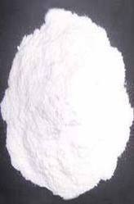

Ans — Poisson’s ratio

Level - 1

Q3. Who made me ?

ans : Martin Campbell

Q4. I love my lappy.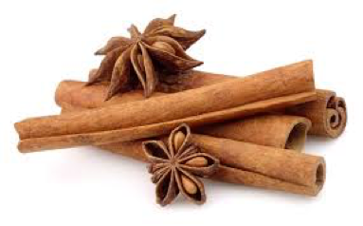

Ans: Linux Mint.

Q5. 

X 3 = who made me?

Ans - Tim Berners Lee and Robert Cailliau